Logo%20Main%20200

**Boston University**

**Electrical & Computer Engineering**

**EC463 Capstone Senior Design Project**

**Problem Definition and Requirements Review**

Mars Rover: Autonomous Navigation

Submitted to

Osama Alshaykh

8 St.Mary’s Street

Room 424

858-361-9043

[osama@bu.edu](mailto:osama@bu.edu)

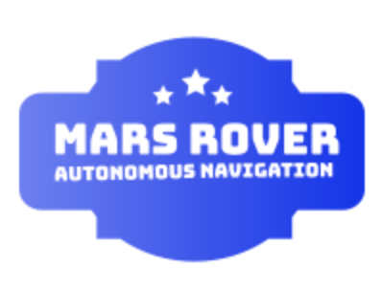

by

Team #28

Rover Boi

Team Members

Daniel Crawley crawley@bu.edu

Brian He brianhe@bu.edu

Tommy Lam tlam11@bu.edu

SeungYeun Lee sylee538@bu.edu

Linden Vo [lindenvo@bu.edu](mailto:lindenvo@bu.edu)

Submitted: TBD

**Customer Sign-Off _______________________________________**

#### Mars Rover: Autonomous Navigation System

#### Table of Contents

Project Summary 2

1 Need for this Project 3

2 Problem Statement and Deliverables 4

3 Visualization 5

4 Competing Technologies 6

5 Engineering Requirements 7

6 Appendix A References. 8

# Project Summary

The goal of this senior design project is to design, build, integrate, and test a rover capable of autonomous movement with the use of GPS that can traverse the terrain of Mars or similar and withstand weather and atmosphere conditions using visual navigation and inertial navigation. There will be a system of hardware, such as cameras and sensors, to navigate autonomously. This project is intended to provide solutions to Mars exploration to get more information and to take samples, and also to compete in University Rover Challenge in 2020.

# Need for this Project

Besides extraterrestrial space exploration being one of NASA’s missions, to one day inhabit a planet other than Earth, and seeking and discovering habitable planets, there are many different use cases for autonomous navigation. Human exploration on extraterrestrial spaces such as Mars has currently not been achieved, so the next step is to send rovers and vehicles into space and onto Mars. Many countries are rushing to develop, fabricate, and deploy rovers or orbiters for surveying the planet’s atmosphere and surface. Many have failed, but with the limited amount of successes, a plethora of information has been obtained by humanity on the planet state of Mars. In the future,

The Mars Rover shares similar parallels with self driving cars, search and rescue vehicles, roombas in the sense that they are all smart and connected systems that move around and perform searching tasks. There are potential other useful applications for autonomous navigation with rovers, including disaster rescue and recovery or bomb retrieval and disarming robots.

# Problem Statement and Deliverables

Our mission is to create a vehicle that is able to navigate autonomously and is capable of accomplishing a variety of tasks. In the case of a Mars rover, this vehicle should be able to navigate the harsh Martian terrain without any human input. This is because any signals from Earth would take several minutes to reach Mars. In any other situation where human input is unavailable, the vehicle must be able to quickly make decisions on its own in order to keep itself functioning and completing its goal as fast and effectively as possible, whatever it may be.

Our primary objective is to create a rover that is able to continuously move forward until it reaches some destination or until it finds an object to collect samples. In order to do this, it must be able to avoid obstacles and traverse difficult terrain, primarily rocky, dusty Martian-like topography. It should also be able to identify objects. For example, a rover on Mars is looking for rocks, water, or evidence of water. Our rover should be designed to identify any sort of object we want and could be modified to look for other things in case it becomes repurposed for another use5 such as a human search and rescue rover.

At the conclusion of the project, the team will deliver a fully integrated vehicle as a proof of concept that can also be potentially officially submitted to the University Mars Rover challenge.

# Visualization

Our project model is going to be made in a way that can traverse in harsh terrain similar to Mars.

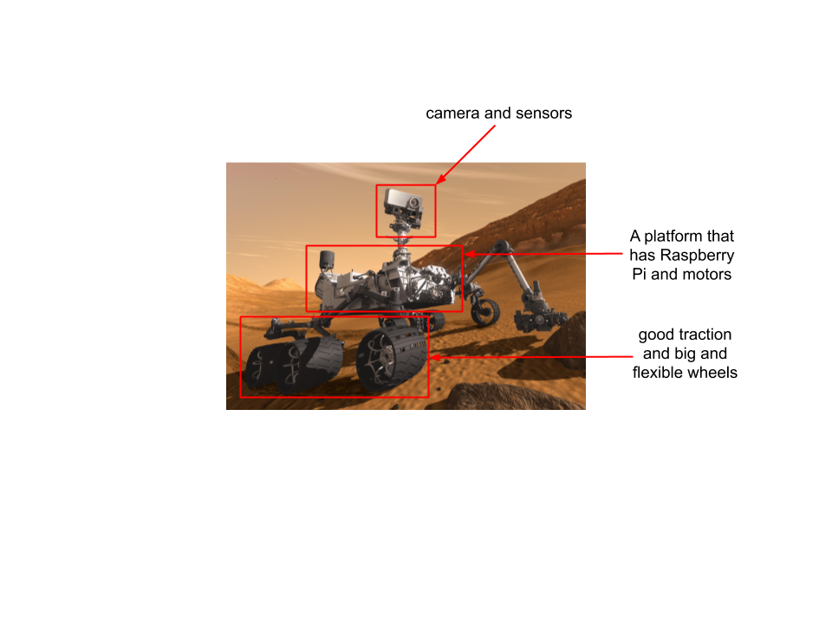

*Figure 1.1 This is an image of an actual NASA rover, and we envision our rover to look similar. We have labeled our proposed hardware components and their locations on the image. We will also have a “kill switch” on the platform that will immediately stop the rover and cease all the power. The cameras and sensors will monitor and detect objects.*

*The wheels will not only have to be big and flexible but also have to have good traction in order to traverse harsh terrain.*

[*https://www.nasa.gov/mission_pages/msl/multimedia/gallery/pia14156.html*](https://www.nasa.gov/mission_pages/msl/multimedia/gallery/pia14156.html)

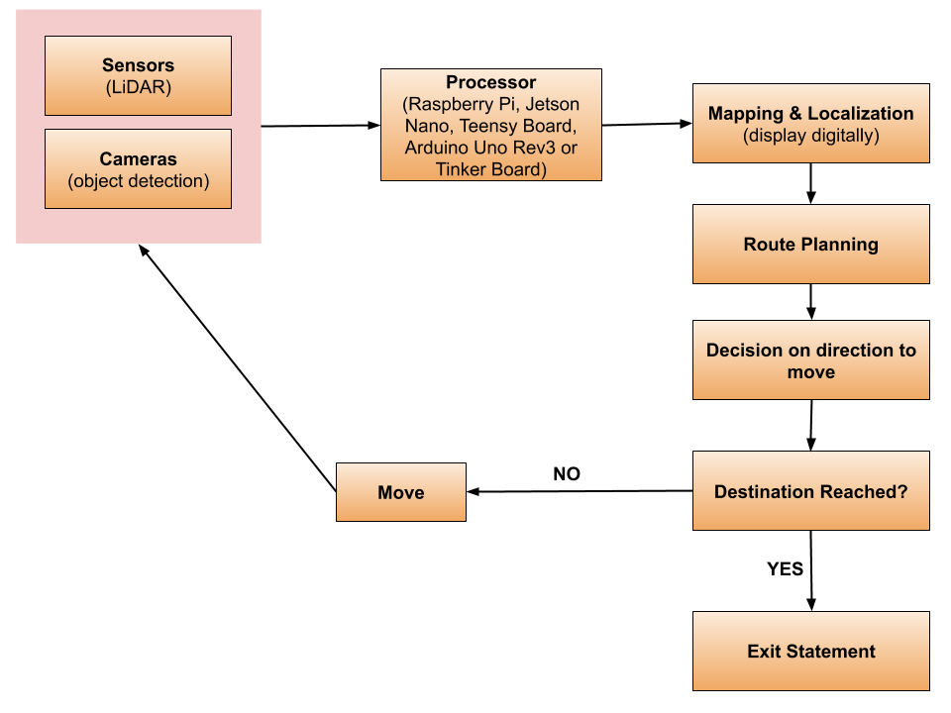

*Figure 1.2 This is a high-level flow chart of the software/hardware side of a rover. We will be controlling our rover with this feedback loop. The cameras and sensors will detect obstacles or an object and it will be processed through the processor, where it will carry out all the tasks. The rover will be mapping and localizing in order to plan its path. Once it plans its route, it will make its own decision on which direction to move. If the destination is reached, then it will stop moving. If it has not reached its destination, then it will keep moving and detect obstacles or objects.*

# Competing Technologies

Autonomous navigation represents a major innovation in modern society. In addition to the competition teams for the University Mars Rover Challenge, there are many companies and universities conducting research on autonomous navigation technology. Some prominent figures include Berkeley DeepDrive and Amazon Robotics.

The Berkeley DeepDrive Industry Consortium focuses their research on state-of-the-art technologies in computer vision and machine learning for automotive applications. They've developed the CAFFE framework, which serves as the foundation for much of the center's work. Their framework has been used by a variety of industries and are currently pursuing to find use cases in the autonomous navigation (Berkeley DeepDrive).

Amazon is an American multinational technology company based in Seattle, Washington, that focuses on e-commerce, cloud computing, digital streaming, and artificial intelligence. In 2012, Amazon purchased Kiva Systems, a warehouse robotics manufacturer, and subsequently deployed its technologies across its broad network of warehouses (Kim). These robots communicate with each other to autonomously traverse the warehouse and automate the entire process of picking up and packaging. The robots have cut operating expenses by about 20%, which translates to roughly $22 million in cost savings for each fulfillment center (CK).

Our Mars Rover project will be most similar to other competing teams in the University Mars Rover Challenge. Berkeley DeepDrive and Amazon Robotics autonomous navigation uses mainly focus on collision free navigation on flat, commercial areas, roads and warehouses. Our rover will be autonomously navigating harsh terrain similar to that of Mars. The main differentiator is that we are navigating on terrain that is rough and in extreme weather conditions, factors that autonomous machines on Earth do not factor in. Our main challenge will these obstacles rather than avoiding other vehicles.

# Engineering Requirements

The following requirements have been specified by the University Rover Challenge requirements and guidelines document:

1. The rover shall be a stand-alone, off-the-grid, mobile platform. Tethered power and communications are not allowed. A single connected platform must leave the designated start gate.In the open field, the primary platform may deploy any number of smaller sub-platforms, so long as the combined master/slave sub-platforms meet all additional requirements published.
2. The rover must fit in a **1.2m x 1.2m**  box. It can fold itself to fit in the box, but cannot be disassembled to do so.
3. Maximum allowable mass when deployed is **50kg.** Total mass of all fielded rover parts is **70kg**.
4. Rovers shall utilize power and propulsion systems that are applicable to operations on Mars. Air-breathing systems are not permitted: No power or propulsion system may ingest ambient air for the purpose of combustion or other chemical reaction that yields energy. Neither can it be airborne.
5. All rovers shall have a “kill switch” that is readily visible and accessible on the exterior of the rover.This switch shall immediately stop the rover’s movement and cease all power draw from batteries in the event of an emergency such as a battery fire.
6. For the sake of the competition, the rover must be remotely operable (beyond line of sight) as a failsafe mechanism. The communications mechanism will be made by another team.
7. The system must be able to read an AR tag from 10m distance
8. The system must be able to autonomously navigate itself to a specified GPS coordinate.
9. The system must be able to recognise and pass through a gate.
10. There must be an LED indicator on the back of the rover, visible in bright daylight that will signal:
    1. Red: autonomous mode
    2. Blue: Teleoperation
    3. Flashing Green: Successful completion of leg of a challenge.

# Appendix A References.

1. CK. “Amazon Says Fully Automated Shipping Warehouses Are at Least a Decade Away.” *The Verge*, The Verge, 1 May 2019, www.theverge.com/2019/5/1/18526092/amazon-warehouse-robotics-automation-ai-10-years-away.

2. Shields, Nicholas. “Amazon Is Rolling out New Warehouse Robots.” *Business Insider*, Business Insider, 15 May 2019, www.businessinsider.com/amazon-introduces-new-warehouse-robots-2019-5.

3. Kim, Eugene. “Amazon's $775 Million Deal for Robotics Company Kiva Is Starting to Look Really Smart.” *Business Insider*, Business Insider, 15 June 2016, www.businessinsider.com/kiva-robots-save-money-for-amazon-2016-6.

4. “Berkeley DeepDrive.” *Berkeley DeepDrive | California Partners for Advanced Transportation Technology*, path.berkeley.edu/research/berkeley-deepdrive.